Start with a clear vision: Define your design vision and communicate it to everyone in the company. Make sure that everyone understands the role of design in the company's mission and goals.

Build a design team: Hire a team of talented designers who are passionate about your company's mission and vision. Look for designers who have a wide range of skills and experience, and who can work collaboratively with other teams.

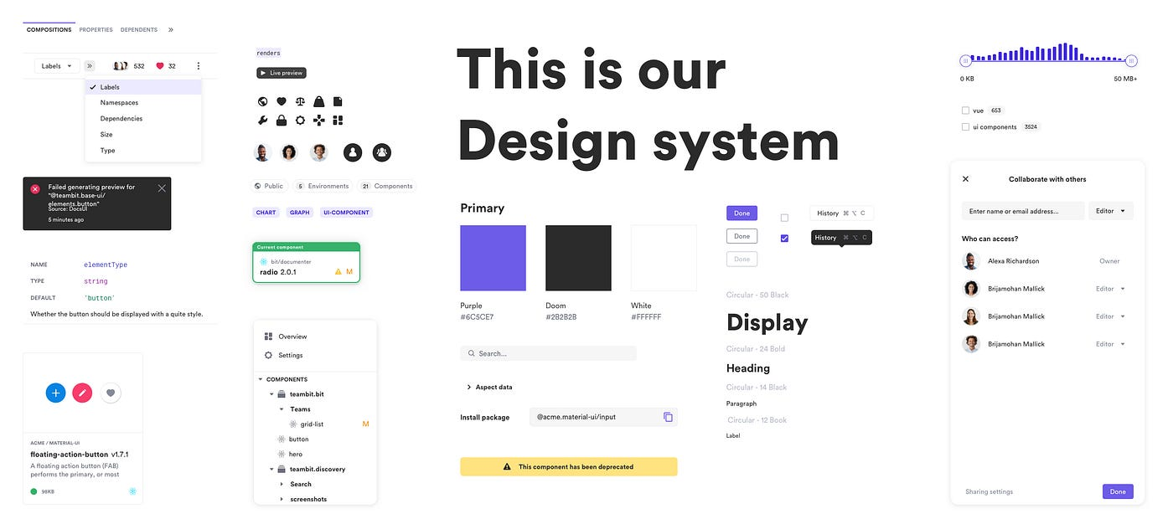

Create a design culture: Establish a culture of design in the company. Encourage everyone to think about design and its impact on the user experience. Foster a culture of experimentation and learning, where designers can try new things and learn from their mistakes.

Integrate design into the company's processes: Design should be integrated into all aspects of the company's processes. Make sure that designers are involved in product development, marketing, and other key functions.

Measure the impact of design: Set up metrics to measure the impact of design on the company's performance. Use these metrics to demonstrate the value of design to other teams and executives.

Scale design: As the company grows, scale the design function accordingly. Hire more designers, establish design processes, and create a design system that can be used across the company.

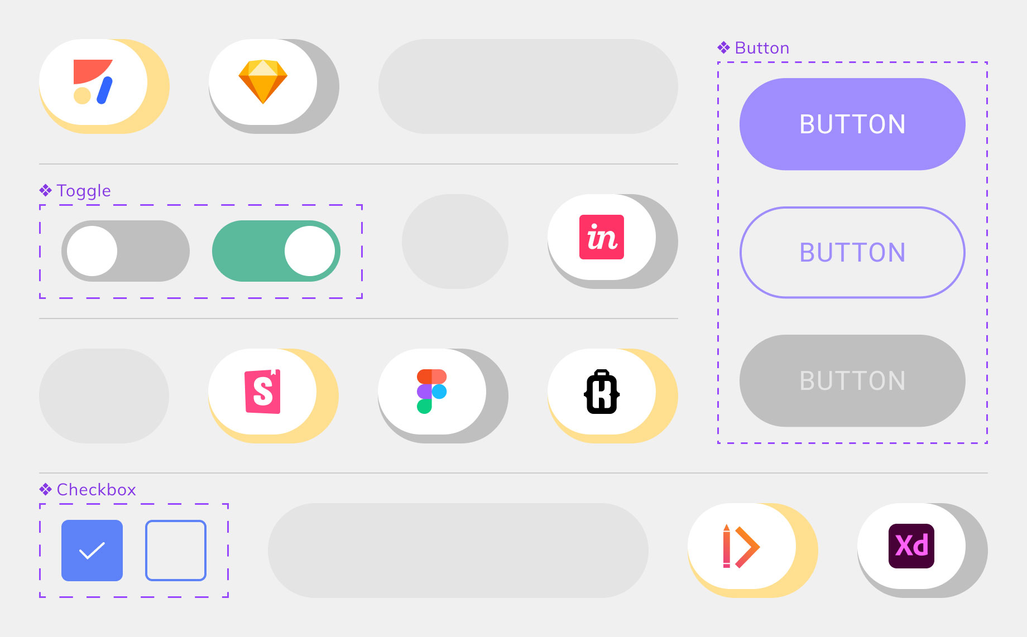every element need it colored prototype

Empower designers: Give designers the resources and support they need to do their best work. Create a supportive environment where designers can take risks and experiment.

